CS311 Yoshii - Week 7 A (Notes-7A) Graphs (Introduction)
======================================================
In preparation for HW6, be able to answer all the Inter questions.
- Are you thinking in terms of when to use which algorithm and data structure?
Graphs are covered in Chapter 8 of the text book (page 381).

Data Structure Agenda:
- Definitions
- Application areas
- Representation/Implementation

Graph Definition and Terminology

Graph G is a pair (V, E)

where V is a set of vertices/nodes (finite and non-empty)
E is a subset of all pairs of vertices from V == undirected edges (lines)

In many books, the notation { X, Y } is an undirected edge between X and Y

Directed Graph G is a pair (V, E)

where V is a set of vertices/nodes (finite and non-empty)
E is a set of ordered pairs of vertices from V == directed edges (arrows)

In many books, the notation (X, Y) is a directed edge X --> Y
tail head

You cannot have a mixture of directed and undirected edges. All lines or all arrows.

Not permitted for the Algorithms in the Book to work:

X -- X or X --> X edge to itself (loop)

X --- Y and X -- Y two undirected edges between X and Y

X --> Y and X --> Y two directed edges in the same direction

*Inter* In what way does the above definition deviate from trees?
Hint: draw two cases not allowed in a tree.

We will write an edge as vw whether it is for a graph or directed graph.

Subgraph of G has subset of V and subset of E. Basically, a part of a graph.

vw means v and w are incident with this edge.

A path is a sequence of edges where all vertices are distinct.
The length of a path is the number of edges.

a -> b -> c -> d the length is 3

Cycle is a path where the start and end are the same

a -> b -> c -> a

Acyclic means there are no cycles. Trees are acyclic.

Weighted graph means weights are placed on edges

Weights may represent things such as miles, prices and effort.

Adjacency set of vertex x == which vertices can you go to from x
in following just one edge? i.e. right next door

Degree of vertex -> count the edges attached to the vertex
In-Degree of vertex -> count the edges coming in
Out-Degree of vertex -> count the edges coming out

a -> b Out-degree of a is 2
-> c

x -> a In-degree of a is 3
y ->
z ->

Complete Graphs

Complete graph has an edge between every pair of vertices.
This is the most crowded graph. The worst case graph for algorithms.

Complete graphs are very useful in analyzing the worst case of graph algorithms because it has
the worst case number of edges.

(Complete graph: draw examples here for undirected and directed cases with 4 vertices)

Connected Graphs

v is connected to w if there is a path from v to w.

A graph is connected if for every pair of vertices v and w,
there is a path from v to w.
i.e. you have a way to travel from any vertex to any other verteThe smallest connected graph is least crowded. The best case graph for algorithms.

(Connected graph: draw examples here for undirected and directed graphs with 4 vertices)

*Inter1* Is an undirected tree always connected??? Why or why not?

Directed graph
is Strongly Connected if every v is connected to every u.
is Weakly Connected if you disregard the arrows.

Graph Size Analysis

Let N be the number of vertices.

A complete graph has every vertex connected directly to every other vertex.
i.e. there is a direct flight from any airport to any other airpot
*Inter2* Draw an undirected example with 3 vertices.
Draw a directed example with 3 vertices.

- With an undirected complete graph, the number of edges = N*(N-1)/2
Why divided by 2? For an undirected graph, a to b is the same as b to a.
- With a directed complete graph, the number of edges = N*(N-1) ҉҉

A connected graph has to have a path between every pair of vertices.
i.e. there is a way to get from any airport to any other airport
*Inter3* Draw an undirected example with 3 vertices.
Draw a directed example with 3 vertices.

Thus, the minimum number of edges in an undirected connected graph is N-1. ҉҉

*Inter4* How many edges does a tree have? Relate this to the statement above.

But the minimum number of edges in a directed connected graph is N (cycle) ҉҉.

Examples:

100 cities are connected by highways. There is a highway between every pair of cities.
How many highways? 100*99/2

100 cities are connected by flights. There is a direct flight between every pair of cities (bi directional)
How many flights? 100*99

100 cities are connected by highways. There is a way to get from one city to another somehow.
How many highways? 99

100 cities are connected by flights. There is a way to fly from one city to another somehow.
How many flights? 100

Graph Application Areas

A graph can represent
- an airline routes/map
- a computer network
- an electrical circuit
- a binary relation

Questions we can ask about a graph:

1 Cheapest/fastest way to get from X to Y == shortest path from X to Y

2 Is there a direct flight from X to Y? == edge from X to Y?

3 If an airport closes, can we still fly between any other pair of cities?
== if a vertex is removed, is the graph still connected?

4 What are all the cities I can get from X? == find all paths from X

5 How can we connect all the cities with the minimum cost? == find MST

6 Is the binary relation transitive? if X --> Y and Y --> Z then X --> Z?

*Inter5* Can you think of other questions? How do you re-state them in
the context of graphs? Hint: detecting or using cycles

Graph Representation/Implementation

How do we store a graph in your program?

If we stored the graph as is using vertices and pointers, vertices will be of different sizes depending
on their out degree.
Morever, any processing of the graph would involve following the links in the heap.

Method 1: As an Adjacency Matrix (simple solution)

Table entry: T[i,j]
Put 1 in the slot when there is an edge from vi to vj

(Try this for a sample graph)

Is there an edge from i to j? => Look up T[i, j]. Easy.

What are the adjacent vertices of i? => Look up the row for i. Easy.
i.e. T[i,1]? T[i,2]? ....

However…..

*Inter6* For an undirected Graph,
are we duplicating information if all n^2 slots are used?
are there slots which can never be 1??

*Inter7* For a directed graph, how many slots are really required/used?
Hint: each of n vertices can go to (n-1) vertices

*Inter8* Does this allow us to store information on each vertex?
Does this allow us to store information on each edge?

Method 2: As Adjacency Lists (we will use this)

Requires more space for each vertex but we can store information about each vertex.

For each vertex vi, store its out degree and the linked list of adjacent vertices.

G contains {vertex name, out-degree, a pointer to adjacent ones}
for all vertices in the graph. We can store more than just the outdegree next to each vertex name.

G
[a| 3| ---> c --> d --> f
[b| 2| ---> f --> g
.
.
[g| 0|

This means a is adjacent to c, d and f (i.e. 3 edges from a)
b is adjacent to f and g (i.e. 2 edges from b)

To answer:

Is there an edge from x to y?
= Search through the adjacency list of x
(if there are M edges in the graph, the linked list is at most length M). Easy.

What are adjacent to x? = Look up the adjacency list of x. Easy.

*Inter9* If you have N vertices and M edges in your graph,
- how many array slots are there in G??
- how many linked nodes are required altogether:
For directed G? Why?
For undirected G? Why?

*Inter10* Can you declare the graph structure in C++?
Hint: It is a table of linked lists.
You already have a linked list class (slist).
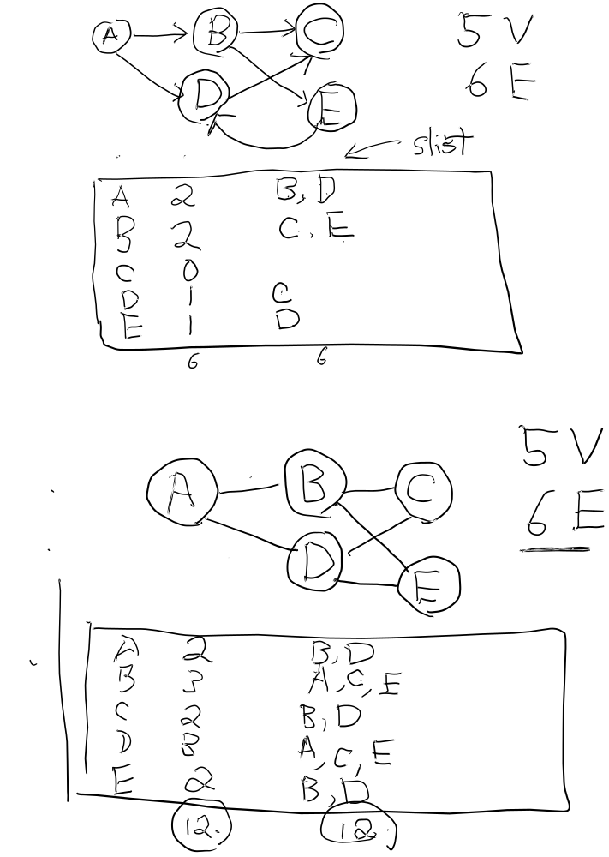

------------------------------------------- ----------------------------------------------------------------
(** Go over HW6, SpecialDemo.out, HW6_help, and GraphAssignment files **)
Using the HW6_help file, first, write a program to read from an input file into Gtable.
Then, display Gtable contents. Test it on sample graphs.

Next: we will cover graph traversal algorithms
- Depth First Traversal
- Breadth First Traversal

EX7A- Graphs - 5 pts

PRINT full names first: Aiman Madan, R-Gee Capili, Ryan Lawson.

1. Draw an undirected complete graph with 3 vertices. Give the formula for the number of edges in terms of N.
2. Draw a directed complete graph with 3 vertices. Give the formula for the number of edges in terms of N.
3. Draw the smallest undirected connected graph with 3 vertices. Give the formula for the number of edges in terms of N.
4. Draw the smallest directed connected graph with 3 vertices. Give the formula for the number of edges in terms of N.
5. If my directed graph has 200 cities, and I want to make sure there is a direct flight from any city to any other city, how many flights are needed? Give the formula first. (complete G)
200x(200-1) = 39800 flights
6. If my undirected graph has 200 cities, and I want to make sure I can drive from any city to any other city somehow, how many roads are needed? Give the formula first. (connected G)
200-1 = 199 flights

